Question 1:

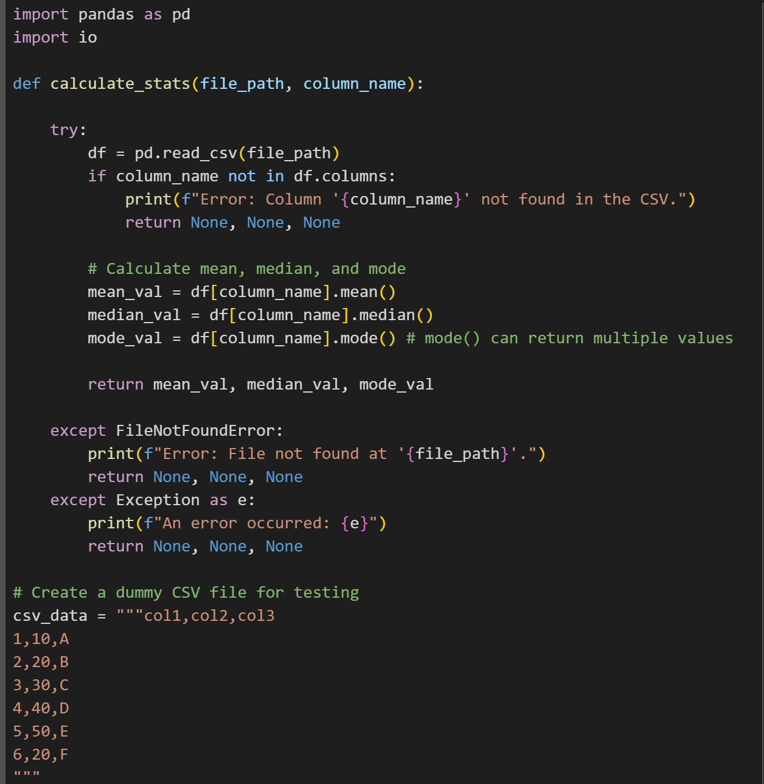

Output:

Question 2:

Output:

Question 3:

Output:

Explanation:

Question 4:

Output:

Question 5:

Output:

